A PROJECT REPORT
ON

IOT MEDTECH: ADVANCING HEALTHCARE THROUGH INTELLIGENT CONNECTIVITY

BY

ROCHAK SHARMA (2001321550038)

SHAMI GAFFAR (2001321550046)

SHRESHTHA GUPTA (2001321550049)

UNDER THE GUIDANCE OF

Mr. XYZ



DEPARTMENT OF COMPUTER SCIENCE & ENGINEERING
GREATER NOIDA INSTITUTE OF TECHNOLOGY ENGG.INSTITUTE, GREATER NOIDA

Dr. A.P.J. Abdul Kalam Technical University, Lucknow

May, 2026


Department of Computer Science & Engineering
Session 2025-2026
Project Completion Certificate
Date: 25/4/2026

This is to certify that Mr. Rochak Sharma bearing Roll No.2001321550038, student of 4th year CSE has completed project program (KCS-851) with the Department of CSE from 26-Feb-2026 to 30-May-2026.

He worked on the Project Titled “IoT MedTech: Advancing Healthcare Through Intelligent Connectivity” under the guidance of Mr. xyz.

This project work has not been submitted anywhere for any degree.

Mr. xyz Prof. (Dr.) S.P.S Chauhan

Assistant Professor, CSE HoD-CSE



Department of Computer Science & Engineering
Session 2025-2026
Project Completion Certificate
Date: 25/4/2026

This is to certify that Mr. Rochak Sharma bearing Roll No.2001321550038, student of 4th year CSE has completed project program (KCS-851) with the Department of CSE from 26-Feb-2026 to 30-May-2026.

He worked on the Project Titled “IoT MedTech: Advancing Healthcare Through Intelligent Connectivity” under the guidance of Mr. xyz.

This project work has not been submitted anywhere for any degree.

Mr. xyz Prof. (Dr.) S.P.S Chauhan

Assistant Professor, CSE HoD-CSE



Department of Computer Science & Engineering
Session 2025-2026
Project Completion Certificate
Date: 25/4/2026

This is to certify that Mr. Rochak Sharma bearing Roll No.2001321550038, student of 4th year CSE has completed project program (KCS-851) with the Department of CSE from 26-Feb-2026 to 30-May-2026.

He worked on the Project Titled “IoT MedTech: Advancing Healthcare Through Intelligent Connectivity” under the guidance of Mr. xyz.

This project work has not been submitted anywhere for any degree.

Mr. xyz Prof. (Dr.) S.P.S Chauhan

Assistant Professor, CSE HoD-CSE

ACKNOWLEDGEMENT

We would like to sincerely thank to our Supervisor Mr. XYZ , our project coordinator Dr. XYZ, and all of the professors for their counsel, inspiration, and unwavering support over the course of our project work. Without their assistance and insightful recommendations, our task would not have been feasible. We are deeply grateful to our esteemed Department Head, CSE (Dr.) Sanjay Pratap Singh Chauhan, for his counsel and assistance when needed.
We are also thankful to Dr. Dheeraj Gupta, our director, for providing the resources we needed to complete our project job effectively.
We would like to express our gratitude to all of our friends for their support and helpful advice throughout this effort. Finally, we have no words to express our sincere gratitude to our parents who have shown us this world and for everything they have given to us.

I

ABSTRACT

The incapacity to move one's muscles voluntarily is a symptom of paralysis. It happens when there is damage to the neurological system that prevents the brain and muscles from properly transmitting messages to each other. Paralysis can result from a number of conditions, such as multiple sclerosis, Parkinson's disease, stroke, and Guillian Barre syndrome. Furthermore, trauma to the neck or spinal cord that results in fractures can also result in paralysis due to damage to the neurological system.
We suggested an IoT MedTech device to help paralyzed patients communicate. This device is an Internet of Things system that allows patients to communicate basic needs and emergency messages by just moving their finger to display the required message. By allowing patients to express themselves, this approach hopes to increase their motivation.
Patients who use finger gestures to express their needs are able to receive better treatment and support. An attendant is alerted when a message is displayed by the Wi-Fi module coupled to the microcontroller in the proposed IoT MedTech gadget. This function makes sure that caregivers are informed as soon as possible about the patient's needs, so they can offer support in a timely manner.
The technology combines the use of finger movements with an alert system to improve communication and assistance for those who are paralyzed in a comprehensive manner. The overall goal of the proposed IoT MedTech is to empower patients who are paralyzed by allowing them to communicate their needs and emergency messages and by enabling effective caregiver response via the use of IoT-based systems. This strategy seeks to enhance the general well-being and quality of life for those who are paralyzed.

II

INDEX
TABLE OF CONTENT

CHAPTER | TITLE | PAGE
1  2  3  4 | CERTIFICATE ACKNOWLEDGEMENT ABSTRACT  LIST OF FIGURE LIST OF TABLE INTRODUCTION  - INTRODUCTION  - PROBLEM STATEMENT  - IDENTIFICATION AND NEED  - OBJECTIVE  - UNIQUENESS OF THE INNOVIATION  - APPLICATIONS OF IOT MEDTECH  - POTENTIAL AREAS OF APPLICATION IN INDUSTRY/MARKET IN BRIEF  - MARKET POTENTIAL OF IDEA/INNOVIATION  LITERATURE SURVEY  - REVIEW OF LITERATURE  PROBLEM FORMULATION AND PROPOSED WORK  - PROBLEM STATEMENT  - PROPOSED SYSTEM  - ADVANTAGE OF PROPOSED SYSTEM  - LIMITATIONS  FEASIBILITY STUDY  - TECHNICAL FEASIBILITY  - ARDUINO IDE  - FORCE SENSOR  - ESP 32  - RESISTOR  - LCD MODULE  - LED  - BREADBOARD  - STRUCTURE AND CONFIGURATION  - TERMINAL STRIPS  - BUS STRIPS  - RESUABLE PROTOTYPING  - COMPONENT PLACEMENT  - LIMITATIONS  - EDUCATIONAL SIGNIFICANCE  - EVOLUTION AND VARIATIONS | I IV V VI VII 1-5  01  02  03  03  04  04  04  05  6-11  6  12-14  12  13  14  14  15-50  15  15  16  20  23  28  31  36  38  38  38  38  39  39  39  39

III

5  6  7  8 | 4.1.7.9 SOURCES  - JUMPER WIRES  - USB TYPE B CABLE  4.2 ECONOMIC FEASIBILITY  METHODOLOGY  - METHODOLOGY  RESULT AND DISCUSSION  - PROTOTYPE MODEL  - COMPARATIVE STUDY  - COMPARATIVE ANALYSIS BASED ON COST  - BCI TECHNOLOGY  - BENJAMIN CHOI’S ROBOTIC ARM:  - SMART GLOVES  - IOT MEDTECH  - COMPARATIVE ANALYSIS BASED ON KEY FEATURE AND TECHNOLOGY  SCREENSHOT  FUTURE SCOPE AND CONCLUSION REFERENCES  PLAGIARISM REPORT  PUBLISHED RESEARCH PAPER/PATENT | 41  41  47  50  51-52  51  53-58  53  54  54  54  54  55  55  56  59-62  63  64  ……..  ……..

LIST OF FIGURES
Fig 1: Block Diagram of IoT MedTech 13
Fig 2: Arduino IDE 16
Fig 3: Force Sensor 19
Fig 4: ESP 32 22
Fig 5: Resistor 27
Fig 6: LCD Module 31
Fig 7: LED 35
Fig 8: Breadboard 41
Fig 9: Jumper Wire 46
Fig 10: USB Type B Cable 49
Fig 11: Schematic Diagram of IoT MedTech 52
Fig 12: Prototype Model 53
Fig 13: Screenshot 1 59
Fig 14: Screenshot 2 59
Fig 15: IoT MedTech Advancing Healthcare 60
Fig 16: Food Message 60
Fig 17: Water Message 61
Fig 18: Medicine Message 61
Fig 19: Telegram Bot 62

LIST OF TABLE

Table 1: Economic Feasibility 50

Table 2: Comparative Analysis Based on Cost 54

Table 3: Comparative Analysis Based on Key Features 56

Table 4: Comparative Analysis Based on Technology 58

Chapter 1 Introduction

Introduction

The Internet of Things MedTech presents a cutting-edge Internet of Things (IoT)-based automated communication system that enables effective hand gesture communication, empowering patients who are paralyzed. This approach improves overall quality of life by facilitating the expression of wants, wishes, and emotions through the use of wearable gadgets, sensors, and sophisticated gesture recognition algorithms. Sensors that can record deft hand motions and movements.
The system's central component is a device, that consists of multiple force sensor which takes input from the patient and the collected data is wirelessly sent by these sensors to an Internet of Things platform for immediate processing and analysis.
The IoT platform translates the recorded hand movements into predetermined instructions or messages. Every gesture has a distinct meaning or action,such as asking for help, expressing discomfort or pain, or interacting with a caregiver. The intended receiver is then informed of the translated commands via an interface, such a display panel or a smartphone application.
Personalized gesture mapping is made possible by the IoT MedTech extraordinary capacity to be tailored to the skills and preferences of specific patients. The platform ensures precise and dependable communication by learning and adapting to the distinct motions of each patient.

Moreover, the IoT platform keeps an extensive log of gesture-based interactions, giving healthcare providers and caregiver’s useful historical data to work with. This data makes it possible to have a deeper understanding of the patient's communication styles and requirements over time, which makes it possible to provide more individualized and focused treatment and assess the success of therapies.
This Internet of Things (IoT) automated device gives crippled individuals who might have trouble communicating verbally back their sense of freedom and dignity by providing a dependable and easy-to-use communication method. It lessens annoyance, enabling people to communicate more efficiently and facilitating better treatment that better meets their medical needs.
Improved patient-caregiver communication, more patient satisfaction, better response to patient requirements, and a stronger sense of autonomy for those who are paralyzed are some of the expected consequences of IoT MedTech. All things considered, IoT MedTech has great promise for transforming paralyzed patients' communication, promoting more comprehension and greatly enhancing their general wellbeing.

Problem Statement

Millions of people across the world suffer from condition where somehow they lose the ability of both moving and speaking. A person can have these symptoms due to some accident (e.g., patients in ICUs), age (e.g., older people find hard time in moving and communicating), and medical issues (e.g., partial paralysis, astasis, quadriplegia, stroke, Parkinson, spinal cord injuries, fractures of the neck etc.). These people often experience difficulties with mobility, independence, and communication, which can severely impact their quality of life.

Identification of Need

- Those people who somehow lost the ability of both moving and speaking (e.g., partial paralysis, astasis, quadriplegia, stroke, Parkinson, old age, people in ICUs, etc.), and find hard time in communication.
- Existing solution include Brain Computer Interface (BCI) systems, exoskeletons and eye status monitoring. But, the devices using these technologies are expensive, sophisticated, and put an additional burden on the patient. Can’t locate the location of the normal blind stick user when they are having an emergency problem or lost in a public area.

Objective

Paralysis is a condition characterized by the inability to voluntarily move one's muscles. It occurs when damage to the nervous system disrupts the proper transmission of messages between the brain and the muscles. Several factors can lead to paralysis, including diseases like Parkinson's disease, multiple sclerosis, Guillian Barre Syndrome, and stroke. In addition, accidents resulting in spinal cord injuries or fractures of the neck can also cause paralysis by damaging the nervous system. To address the communication challenges faced by paralyzed patients, we proposed IoT MedTech device - an IoT based system that enables them to convey their basic requirements and emergency messages simply by moving their finger to display the desired message.
Overall, our proposed system seeks to empower paralyzed patients by enabling them to express their needs and emergency messages, while also facilitating efficient caregiver response through
IoT based system. This approach aims to improve the quality of life and overall well-being of individuals living with paralysis.

Uniqueness of the innovation
The proposed solution is handy and affordable. The proposed solution offers dynamic patterns. The IoT med tech device relies on interpreting the patterns captured by force sensors. And, different people may intend to have their own set of patterns to convey their messages. For example, a patient may choose alphabets like “A”, “B” and “C” as their pattern and another patient may choose some art figures like circle, drawing, and square to convey the message. The IoT med tech device offers the configuration setting to store these patterns.
The device will also be attached to the smart phones of the care giver and the support community to alert them any time the patient needs. The patient can choose to convey the message via LCD or notification procedure in the application. The device will also be using cloud storage to maintain the history of communication.
The proposed device can also be used by hospitals to provide advanced facilities to the patients admitted in ICU. Elder people can also use this device to have communication without much efforts.

Applications of IoT MedTech
    - Potential areas of application in industry/market in brief
The IoT-based MedTech provides various application in the domain of health care which are listed as follows:
      - Provide innovative solutions for nursing home care, specifically for paralyzed patients, to improve clinical outcomes without constant nursing presence.
      - Benefits for Grades A and B Paralytics: The proposed gear, combining hardware and software, offers significant benefits for paralyzed patients in Grades A and B, enabling communication for emergencies and basic needs at an affordable price.
      - Accessibility and Usability: Ensure the IoT-based technology is user-friendly and accessible for individuals with varying educational backgrounds, making it applicable in diverse healthcare settings.

      - The anticipated outcomes of this project include enhanced patient-caregiver communication, increased patient satisfaction, improved responsiveness to patient needs, and a greater sense of autonomy for paralyzed individuals. Overall, the IoT- based automated communication system has the potential to revolutionize communication for paralyzed patients, fostering better understanding and significantly improving their overall well-being.
      - Furthermore, the IoT platform maintains a comprehensive record of gesture-based interactions, providing caregivers and healthcare professionals with valuable historical data for analysis. This information enables a deeper understanding of the patient's communication patterns and needs over time, facilitating more personalized and targeted care and helping evaluate the effectiveness of interventions.

Market potential of idea/innovation
      - The proposed device can be utilized by hospitals to provide advanced health facility to their patents at an affordable price.
      - The proposed device can also be utilized by support group of patients to take better care and have communication. One of the remarkable aspects of this system is its ability to be customized to individual patients' capabilities and preferences, allowing for personalized gesture mappings. The platform can learn and adapt to each patient's unique gestures, ensuring accurate and reliable communication.

Chapter 2 Literature Survey
2.1 Review of Literature
Khan et al. [2] focused on the development and implementation of an IoT-based health surveillance system. This system allows users to monitor their health parameters using IoT devices, enabling them to proactively manage their well-being. When necessary, patients can seek medical assistance based on the data collected. The system facilitates convenient communication of medical information to physicians through a single application. Physicians can remotely monitor patients' conditions, regardless of distance. By measuring temperature, pulse rate, and oxygen saturation levels, the IoT device collects data, which is then transmitted to the application via Bluetooth. The data is also displayed on the screen, providing patients with a quick overview of their current health status. This method proves beneficial for elderly individuals, asthma and Emphysema patients, those with chronic illnesses, COVID-19 patients, and individuals with diabetes, enabling them to maintain their long-term health effectively.
In their innovative approach to address sudden death rates, Krishnan et al. [3] introduced Patient Health Tracking, a system that utilizes monitoring and internet connectivity to enable communication with loved ones during critical situations. The system incorporates temperature and pulse sensors to track health indicators. A microprocessor is connected to a display screen, allowing for real-time health monitoring, while wireless connectivity transmits the collected data to a web-based server. This setup ensures continuous tracking and provides a means for timely intervention and support.
The researchers implemented an IoT-based system that utilizes sensors to detect sudden changes in a person's body temperature or pulse. When such changes occur, the IoT system sends immediate notifications to the individual. Furthermore, this system collects real-time patient temperature and pulse data, incorporating date stamps for accurate record-keeping and analysis.

Hadis et al. developed a patient tracking system that utilizes Android applications to display electronic findings. The system also incorporates the ability to recognize threshold values of physiological parameters, assess the severity of these parameters based on the patient's condition, and generate alerts for abnormal conditions. This innovation significantly reduces the workload for nurses and provides a more practical approach to monitoring vital signs of patients throughout the ward. The traditional method, which involves physicians physically visiting each patient to check their heart rhythm, is time-consuming. However, with this system, nurses can conveniently monitor patients' conditions using Android applications that can be installed on any Android smartphone. Additionally, healthcare professionals can easily evaluate the previous vital sign status by retrieving information from the cloud in the form of an Excel spreadsheet.

Richa et al. introduced a patient medical surveillance system designed for widespread use in real emergencies. This system enables regular inspection, recording, and storage of medical data in a database. The IoT device can also be seamlessly integrated with laptop computers, allowing for the transfer of the database between critical care and therapy facilities. This system proves to be highly valuable, especially in pandemic situations, where efficient and secure medical data management is crucial.

Monitoring the body temperature, heartbeat, and blood oxygen levels are essential measures for trauma patients. In their study [7], Khan et al. introduce an IoT-based approach that serves as a comprehensive health surveillance system, focusing on these key patient parameters. The IoT device incorporates an LCD display that can be easily synchronized with a smartphone app, providing quick access to real-time readings of temperature, heartbeat, and blood oxygen levels. The proposed technique utilizes an Uno-based system and has undergone testing and validation with five individuals.

Abdulmalek et al. explored the use of IoT in healthcare surveillance systems, examining current trends and highlighting the advantages of IoT-based health services. Through a thorough analysis of literature, the study provides a comprehensive evaluation of recent research on medical surveillance systems utilizing IoT.

The evaluation compares the efficacy, effectiveness, data security, confidentiality, privacy, and surveillance capabilitiesof various systems. Additionally, the researchers delve into IoT surveillance systems that leverage wireless and wearable sensors, offering a taxonomy of healthcare monitoringsensors. This review study offers valuable insights into the utilization of IoT in healthcare surveillance and contributes to a deeper understanding of its potential benefits and challenges.

Rohith et al. developed a Patient’s Healthcare Monitoring System using an ESP8266 and a Uno microcontroller. The team utilized Thing Speak as the interactive system for this project. Through the HTTP protocol, the IoT application and Thing Speak API facilitated the storing and retrieval of data from connected devices over a local area network (LAN) or the internet. The IoT device monitored pulse 0rate and temperature, continuously collecting data and transmitting it to an IoT platform. The system incorporated an oximeter detector to measure Pulse Beat (BPM) and Elevated Heart Rate (HR/BPM), while the LM35 sensor module was used to measure body temperature. To ensure patient comfort, the system maintained a specific humidity and temperature ratio in the patient's environment. This careful control of environmental conditions aimed to provide a comfortable space for the patient during monitoring.

M Mohana, S Priyadharshini, N Sowmiya, and GP Devi proposed an IoT-based automated communication system for paralyzed patients using simple hand gestures. Paralysis, characterized by the inability to move muscles, results from damage to the nervous system, disrupting the communication between the brain and muscles. Various conditions such as Parkinson's disease, multiple sclerosis, Guillain-Barre Syndrome, stroke, accidents leading to spinal cord injury, or broken necks can cause paralysis. The objective of their system is to assist paralyzed patients in conveying basic needs and emergency messages through finger movements, enabling them to communicate effectively. By utilizing hand gestures, the patient can display the required message, thereby enhancing their motivation and autonomy. Additionally, the system includes a buzzer to alert caregivers or attendants when a message is displayed, ensuring prompt assistance.

"Smart healthcare security device on medical IoT using Raspberry Pi," authored by S. Sengan,
O. I. Khalaf, S. Priyadarsini, D. K. Sharma, K. Amarendra, and A. A. Hamad, the focus is on enhancing the security of two-wheelers through the implementation of an innovative technology solution. The study, published in the International Journal of Reliable and Quality E-Healthcare, is structured around two main components: the helmet unit and the vehicle unit. The helmet unit is equipped with sensors to detect proper helmet usage by the rider, as well as an alcohol sensor to ascertain whether the driver is under the influence of alcohol. Data collected by the helmet unit, including helmet usage status and alcohol detection, is transmitted wirelessly to the vehicle unit using RF transmission. Prior to transmission, the data is encoded for security purposes. Upon receiving the data, the vehicle unit, which includes a Raspberry Pi micro-controller, analyzes the information. If the alcohol sensor detects intoxication, the Raspberry Pi micro- controller activates a driver circuit to control a relay, thereby stopping the vehicle to prevent the intoxicated individual from driving further. The project incorporates a tracking mechanism to monitor vehicle usage on a daily basis. In the event that alcohol consumption is detected while driving, an alarm is triggered, and the vehicle's key is disabled to ensure the safety of the driver and others on the road.
Zhao, Chen, Khan, and Khalafe (2021) focus on the optimization of management processes for the Internet of Things (IoT) in the electronic market, particularly for Small and Medium Electronics Enterprises (SMEE) in China. Quality is identified as a crucial competitive priority for SMEEs, essential for their survival and growth in the market. However, these enterprises face challenges due to limited validation capital, which hampers their ability to compete effectively. To address these challenges, continuous measurement of quality is emphasized, regardless of the product type. This approach enables firms to effectively deploy IoT-assisted identify management (IIDM) models, which facilitate the identification and resolution of quality issues. By implementing IIDM, SMEEs can allocate resources efficiently and focus on areas that contribute to improved quality outcomes, rather than wasting resources on non-productive activities. The authors highlight the importance of analyzing Total Quality Management (TQM) to better understand the relationship between internal and external structures within SMEEs. This understanding is crucial for achieving better quality results and enhancing competitiveness in the electronic market.

"E-health monitoring system," presented at the International Conference on Applied Internet and Information Technologies in 2016, A. Kotevski, N. Koceska, and S. Koceski highlighted the limitations of traditional patient monitoring systems, which are often confined to hospitals or healthcare centers. They emphasized the potential benefits of remote monitoring systems facilitated by advancements in information and communication technologies. The proposed e- health system aimed to enable doctors to monitor patients' vital parameters regardless of their location, thereby reducing costs, travel time, and improving overall efficiency and user satisfaction. The integration of web, mobile, and smart TV technologies was proposed to enhance accessibility to patients' data and facilitate improved communication between patients and doctors. This holistic approach sought to leverage various platforms to provide seamless access to vital health information, thereby enhancing the quality of care provided to patients.

N. S. M Hadis, M. N. Amirnazarullah, M. M. Jafri, and S. Abdullah developed a patient monitoring system aimed at detecting and analyzing two primary vital signs: body temperature and respiratory rate. The system, implemented on an IoT platform, was designed using Arduino Mega 2560 and ESP8266 Wi-Fi Module. Each vital sign level was determined using two sensor modules, each equipped with temperature sensors.
The objectives of the project were to design a patient monitoring system capable of detecting vital sign levels, analyzing them based on the patient's age, issuing alerts for abnormal conditions, and wirelessly displaying the results via Android apps. The system aimed to reduce the workload for nurses in hospitals by providing a convenient method for monitoring vital signs for every patient in the ward. Nurses had to visit each patient individually to record vital sign measurements, which was time-consuming. However, with the implemented system, nurses could monitor patient status through Android apps installed on any Android device. Furthermore, nurses or doctors could review previous vital sign statuses by downloading data from the cloud in Excel format. Comparative analysis between the vital signs levels obtained from this system and those from standard measurement equipment or manual observation showed almost identical results. This suggests that the developed IoT-based patient monitoring system is reliable and accurate for monitoring vital signs in a healthcare setting.

Jenifer, M.; Rinesh, S.; Thamaraiselvi, K. presented an Internet of Things (IOT) based Patient Health Care Monitoring System using electronic gadgets. This system is particularly relevant in pandemic situations, as it helps prevent disease spread and facilitates diagnosis even when medical professionals are not physically present. The system consists of an electronic wearable device and a smartphone connected via Wi-Fi. Various sensors are employed to measure crucial physical parameters such as heart rate, temperature, blood pressure, and oxygen supply level. These sensors continuously monitor the patient's health, and the data is transmitted and stored in a cloud server located remotely via Wi-Fi. To implement this system, sensors are connected to an ARDUINO Uno microcontroller, which processes the data and sends it to the cloud server. In case of any abnormalities detected in the patient's health parameters, an automatic alert message, along with the patient's location, is sent to medical specialists via the smartphone. This innovative approach to healthcare monitoring demonstrates the potential of IoT technology in improving patient care, particularly in challenging circumstances such as pandemics. By leveraging wearable devices and cloud-based data storage, this system offers real-time monitoring and timely intervention, ultimately enhancing patient outcomes.

Chapter 3
Problem Formulation and Proposed Work

  - Problem Statement

Millions of people across the world suffer from condition where somehow they lose the ability of both moving and speaking. A person can have these symptoms due to some accident (e.g., patients in ICUs), age (e.g., older people find hard time in moving and communicating), and medical issues (e.g., partial paralysis, astasis, quadriplegia, stroke, Parkinson, spinal cord injuries, fractures of the neck etc.). These people often experience difficulties with mobility, independence, and communication, which can severely impact their quality of life.

Proposed System
To address the communication challenges faced by these patients, we propose IoT MedTech device - an IoT based system that enables them to convey their basic requirements and emergency messages simply by moving their finger.

    - IoT MedTech is an innovative medical device that has the potential to significantly improve the quality of life for those living with partial paralysis.
    - The proposed device includes Wi-Fi module attached with microcontroller that alerts attendants when a message is displayed. This feature ensures that caregivers are promptly notified of the patient's requirements, enabling them to provide timely assistance. By combining the use of finger movements and an alert mechanism, the system offers a comprehensive solution for enhancing communication and support for paralyzed individuals.

    - Force sensor, microcontroller and Wi-Fi module are the main components of the IoT MedTech. Force sensor is used to identify simple finger movements to express a patient's requirements. Sensors attached to the body measure the acceleration, gesture or movement of the fingers. A microcontroller is a compact integrated circuit designed to govern the various operations of the device. It controls all the components of the device. A Wi-Fi module is also connected with microcontroller board which enables the communication.

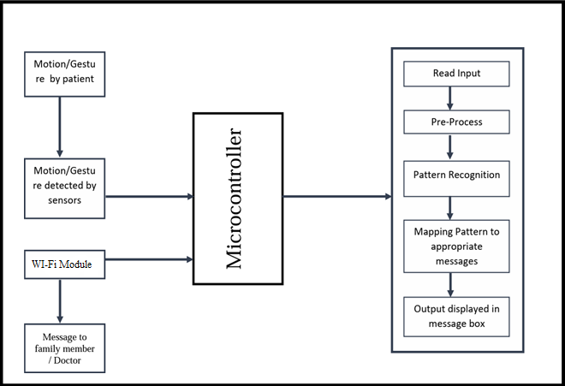

Fig.1: Block diagram of IoT MedTech

ADVANTAGE OF PROPOSED SYSTEM
Advantages of the Proposed System:

- Help the paralyzed people to communicate with the others.

- Easy pattern detection through force sensors.

- Able to draw the patterns easily.

- In case of emergency, able to contact with the family member.

- Easy to detect the problem of the user.

- Implementation cost is low.

Limitations
- In case of defect or repair, troubleshooting of the system is complex.
- This system is not compatible for blind people.

Chapter 4 FEASIBILITY STUDY
  - Technical Feasibility

    - Arduino IDE:

A detachable, dual-inline-package (DIP) ATmega328 AVR microprocessor serves as the foundation for the Arduino UNO R3 microcontroller board. Twenty digital input/output pins are included on it, six of which can be utilized as PWM outputs and the other six for computer programs. Because of its large support base, the Arduino is a fairly simple platform to begin working with embedded electronics.
The Arduino IDE becomes an invaluable tool for documenting code and project details. Its user- friendly interface makes coding easier for both novice and seasoned developers. Developers can include comments and annotations directly in the code, explaining the functionality of particular sections or giving context for particular decisions.
The Arduino IDE, users are presented with an interface that is easy to navigate and caters to a wide range of developers, from beginners to seasoned pros. This interface is quite helpful during the development process since it makes it possible to add comments and annotations straight into the source. These annotations clarify the purpose of particular code segments and offer crucial background information for making decisions throughout the development process.
The Arduino IDE makes it possible to create thorough project documentation with precision. This documentation includes an overview of the project, a description of its goals, and a list of the components that were used, and clear wiring diagrams. Developers may guarantee that this

Documentation becomes an integral part of the project, supporting teamwork, aiding in debugging, and creating the foundation for future project expansion, by incorporating it within the IDE.

The Arduino IDE presents itself as an indispensable tool for developers to document, annotate, and produce thorough reports, going beyond its function as a simple coding environment. By virtue of these characteristics, the Arduino IDE improves the overall effectiveness of the report-making process by streamlining the communication and presenting components of Arduino-based projects.


Fig.2: Arduino IDE

Force Sensor:

Force sensors are used in assistive technology and medical equipment to measure the forces that users or patients apply. Force sensors, for instance, can be included into prosthetic limbs to modify grip strength and offer feedback. By keeping an eye on the distribution of pressure across body surfaces, they can also be used to avoid pressure ulcers.
Force sensors are tools made to measure the force applied to an item, giving useful information about the force's direction and quantity.

These sensors work by translating mechanical force into an electrical signal, which enables quantitative analysis in a range of contexts.
Force sensors find widespread application in diverse fields. In industrial settings, they play a crucial role in quality control, robotics, and material testing. In healthcare, force sensors are employed in medical devices to measure physiological forces, such as blood pressure or grip strength. They are also integral components in human-computer interaction devices like touch screens, providing a responsive interface.
Force sensors are vital in the field of biomechanics for analyzing forces exerted by the human body during activities like walking or exercising. The automotive industry utilizes force sensors for crash testing and vehicle safety systems. With their versatility and precision, force sensors contribute significantly to the advancement of technology across various domains, enabling accurate measurements and enhancing the performance of numerous systems and devices.
Force sensors are devices designed to measure the force applied to an object, providing valuable data about the magnitude and direction of the applied force. These sensors operate on the principle of converting mechanical force into an electrical signal, allowing for quantitative analysis in various applications.
A force sensor, also known as a force transducer or load cell, is a device designed to measure the force applied to it. These sensors play a crucial role in various fields, including engineering, physics, biomechanics, and industrial applications. The fundamental principle behind force sensors is the conversion of mechanical force into an electrical signal, allowing for quantitative measurement and analysis.

At its core, a force sensor comprises a mechanism that deforms under the influence of an applied force. This deformation can be proportional to the magnitude of the force, and the sensor is equipped with elements that transduce this mechanical deformation into an electrical signal. This transduction process enables the force to be accurately quantified and utilized for diverse applications.
Force sensors come in various types, each tailored to specific requirements. Common designs include strain gauge-based sensors, piezoelectric sensors, hydraulic load cells, and capacitive sensors. Strain gauge-based force sensors utilize the strain-dependent resistance of materials to measure force. These sensors typically consist of a flexible material with attached strain gauges that deform with applied force, causing a change in electrical resistance.
Piezoelectric force sensors, on the other hand, employ piezoelectric materials that generate an electrical charge when subjected to mechanical stress. This charge is then measured and correlated with the applied force. Hydraulic load cells utilize fluid-filled chambers and measure the pressure changes caused by force, translating them into an electrical signal.
Capacitive force sensors rely on changes in capacitance between two plates, which vary as a function of the applied force. This change is then converted into an electrical signal for measurement. Each type of force sensor has its advantages and limitations, making them suitable for different applications based on factors such as precision, sensitivity, and environmental conditions.

The force sensor, priced between 350 and 420 rupees, offers precise measurement capabilities for detecting and quantifying forces applied to it and some specifications:
- Range: 0 to 100 Newton’s

- Sensitivity: 0.1 Newton’s
- Resolution: 0.01 Newton’s
- Operating Temperature: -10 to 50 degrees Celsius
- Maximum Overload: 150 Newton’s
- Response Time: 10 milliseconds

Sources: You can purchase force sensors from various sources, including online retailers such as Amazon, electronics suppliers like Digi-Key or Mouser, and specialized sensor manufacturers such as TE Connectivity or Honeywell. Additionally, local electronics stores or industrial equipment suppliers may also carry force sensors. When buying a force sensor, consider factors such as price, specifications, brand reputation, and customer reviews to ensure you get a reliable and suitable product for your application.
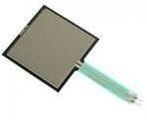

Fig.3: Force Sensor

ESP 32:
The ESP32, developed by Espressif Systems, is a renowned microcontroller platform celebrated for its powerful features and cost-effectiveness. It features a dual-core Tensilica Xtensa LX6 microprocessor, capable of operating at up to 240 MHz, which supports efficient multitasking and complex computations. One of its standout features is the integrated Wi-Fi and Bluetooth capabilities, supporting 802.11 b/g/n Wi-Fi and Bluetooth 4.2, including Classic Bluetooth and Bluetooth Low Energy (BLE), making it ideal for IoT (Internet of Things) applications.
Equipped with a rich set of peripherals, the ESP32 includes multiple UARTs, SPI, I2C, I2S, and PWM interfaces, enabling it to interface with various sensors, actuators, and other hardware components. Additionally, it offers 18 channels of 12-bit ADC (Analog to Digital Converter) and 2 channels of 8-bit DAC (Digital to Analog Converter) for precise analog measurements and signal generation. The ESP32 is designed with energy efficiency in mind, featuring various power modes such as deep sleep, light sleep, and dynamic frequency scaling, crucial for battery- powered devices.
Development for the ESP32 is supported by the ESP-IDF (Espressif IoT Development Framework), a comprehensive software development kit, and it is also compatible with the Arduino IDE, making it accessible to hobbyists and beginners alike. This versatility allows the ESP32 to be used in a wide range of applications, including IoT devices, home automation systems, health monitoring devices, industrial control systems, and robotics. Its connectivity options are particularly beneficial for smart home devices, wearable electronics, and industrial automation.
The ESP32's development environment is further enhanced by an extensive ecosystem of tools and resources. The ESP-IDF provides comprehensive software libraries and example codes,

facilitating rapid development and deployment of applications. For beginners and hobbyists, the Arduino IDE offers a simplified interface and a vast repository of libraries tailored to the ESP32, making it easier to start with basic projects and gradually advance to more complex designs.
In practical applications, the ESP32's low power consumption features are especially advantageous. For IoT devices, the ability to switch to deep sleep mode can significantly extend battery life, making it suitable for remote monitoring systems where battery replacement is impractical. In home automation, the combination of Wi-Fi and Bluetooth connectivity allows the ESP32 to seamlessly integrate with various smart devices, creating a cohesive and intelligent home environment. Health monitoring devices benefit from the ESP32's BLE capabilities, enabling real-time data transmission with minimal power usage, essential for wearable technology.
The ESP32's robust performance and diverse features also make it an excellent choice for industrial control systems. Its multiple I/O interfaces and high processing power enable it to handle complex tasks such as real-time data processing and machine control. In robotics, the ESP32 can manage sensors, motors, and communication systems, providing a versatile platform for building sophisticated robotic systems.
Moreover, the active and growing ESP32 community significantly contributes to its success. Developers continuously contribute to an extensive collection of open-source libraries, tutorials, and forums. This collaborative environment aids in troubleshooting and problem-solving while fostering innovation through the sharing of new projects and ideas.
The ESP32 also supports various operating systems and real-time operating systems (RTOS), such as FreeRTOS, allowing for real-time task management and precise control over hardware resources. This suitability for applications requiring deterministic performance makes it ideal for audio processing, real-time data acquisition, and control systems.

For security-conscious applications, the ESP32 offers robust security features, including hardware encryption, secure boot, and flash encryption, ensuring data protection both at rest and during transmission. These features are particularly important in IoT applications, where security is a major concern due to the increasing number of connected devices.
Additionally, the ESP32 can easily integrate with cloud platforms like AWS, Google Cloud, and Azure. This capability enables developers to build scalable IoT solutions that leverage cloud computing resources for data analytics, machine learning, and remote management.
In educational settings, the ESP32 is frequently used to teach students about embedded systems, programming, and IoT concepts. Its affordability and ease of use make it an excellent tool for hands-on learning and experimentation. Many educational institutions and makerspaces use the ESP32 to introduce students to real-world applications of technology, fostering a new generation of engineers and developers.
Overall, the ESP32's combination of advanced features, extensive connectivity options, energy efficiency, and strong community support makes it a highly versatile and widely used microcontroller. Whether in IoT, industrial automation, health monitoring, robotics, or education, the ESP32 provides a robust platform for innovation and development.

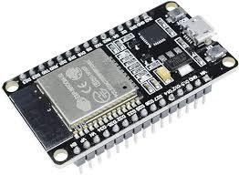
Fig.4: ESP 32

Resistor:

A resistor is a fundamental electronic component that opposes the flow of electric current. Its primary function is to limit or control the amount of current flowing through a circuit. Resistors are ubiquitous in electronic devices, serving a crucial role in regulating voltage, dividing circuits, and protecting components.

The fundamental property that defines a resistor is its resistance, measured in ohms (Ω). Resistance is the opposition to the flow of electric current, and it depends on the material, length, and cross-sectional area of the resistor. The relationship between voltage (V), current (I), and resistance (R) is described by Ohm's Law: V = I * R.
Resistors come in various types and shapes, catering to different applications. One common type is the fixed resistor, which has a predetermined resistance value that remains constant. Variable resistors, on the other hand, allow the adjustment of resistance manually or automatically.
Potentiometers and rheostats are examples of variable resistors frequently used for tuning circuits or controlling volume in electronic devices.
The physical construction of resistors varies based on their intended use. Carbon composition resistors consist of a mixture of carbon and insulating material. Metal film resistors utilize a thin metal film on a ceramic base, providing greater precision and stability. Wire wound resistors employ a coiled wire, often made of a resistive alloy, for applications requiring high power handling capabilities.
Resistors play a crucial role in voltage division circuits, where they create a specific voltage drop

across a portion of the circuit. This principle is frequently applied in voltage dividers, allowing

precise control over voltage levels within electronic systems. Moreover, resistors are integral in protecting sensitive electronic components by limiting the current that flows through them.
In addition to their primary function in limiting current, resistors find application in signal processing circuits. They influence the amplitude and frequency response of signals, contributing to the shaping and filtering of electrical signals. In audio applications, for instance, resistors are commonly used in conjunction with capacitors to design filters that pass or attenuate specific frequency ranges.
Resistors are also vital in the realm of integrated circuits (ICs) and microelectronics. They are employed in pull-up and pull-down resistor networks to establish known states in digital circuits. Pull-up resistors, for example, ensure that an input signal to a microcontroller is in a defined state when no other active device is driving it.
Furthermore, resistors are crucial for safety and power dissipation in electronic systems. High- power resistors can absorb and dissipate significant amounts of heat generated during normal operation. This prevents electronic components from overheating and ensures the reliability of the entire system.
In conclusion, resistors are fundamental components in electronic circuits, providing essential functions such as current limitation, voltage division, and signal processing. Their versatility and widespread use make them indispensable in various applications, from basic electronic devices to complex integrated circuits, contributing significantly to the functionality and reliability of modern electronic systems.

Resistors play a pivotal role in the intricate world of electronics, acting as indispensable components that influence the behavior of electric circuits. Their ability to regulate current flow and manage voltage levels makes them essential for achieving precision, control, and safety in electronic systems.
One significant aspect of resistors is their impact on power dissipation. When electric current passes through a resistor, it encounters opposition, leading to the conversion of electrical energy into heat. This characteristic is particularly crucial in high-power applications where resistors are strategically employed to absorb and dissipate excess energy, preventing overheating and potential damage to sensitive electronic components.
In electronic circuits, resistors are often used in conjunction with other components, such as capacitors and inductors, to form filters that modify the frequency response of signals. This collaborative effort enables engineers to tailor the performance of a circuit to specific requirements, allowing for the selective transmission or attenuation of certain frequencies. The careful integration of resistors in signal processing applications contributes to the creation of audio equalizers, tone controls, and various filtering systems that shape the output signal according to desired characteristics.
The concept of resistance also extends its influence to the field of sensors. In devices like thermistors and photo resistors, the electrical resistance changes in response to variations in temperature or light intensity. This property makes resistors crucial elements in the development of sensors for temperature monitoring, ambient light sensing, and other applications where a measurable electrical response correlates with environmental changes.

Resistors are not confined to passive roles; they actively contribute to the stability and reliability of electronic systems. Pull-up and pull-down resistors are commonly employed in digital circuits to ensure well-defined voltage levels when inputs are not actively driven. This is particularly important in microcontroller-based systems, where maintaining clear and consistent logic states is vital for proper operation.
Variable resistors, including potentiometers and rheostats, offer a dynamic element to circuit design. These components allow users to manually adjust resistance, offering a practical means of tuning circuits, controlling volume in audio devices, or setting specific parameters in various applications. The versatility of variable resistors provides a hands-on approach to circuit optimization, allowing for real-time adjustments to meet changing requirements.
In the context of electronic manufacturing, precision and reliability are paramount. Modern manufacturing processes have led to the development of resistors with high precision and stability, ensuring consistent performance across different units. This is particularly critical in applications such as medical devices, aerospace systems, and communication equipment, where the reliability and accuracy of electronic components are non-negotiable.
In conclusion, the intricate and multifaceted nature of resistors extends beyond their fundamental role in limiting current and controlling voltage. Their impact spans diverse applications, from power dissipation and signal processing to sensor technology and circuit tuning. As electronic systems continue to evolve, resistors remain at the forefront, contributing to the efficiency, stability, and adaptability of modern electronics.

The resistor is available at prices ranging from a minimum of 2 rupees to a maximum of 3 rupees and some specifications:
- Resistance value: Expressed in ohms (Ω)
- Tolerance: Percentage indicating the maximum deviation from the specified resistance value
- Power rating: Maximum power the resistor can dissipate without damage, typically in watts (W)
- Temperature coefficient: Change in resistance per degree Celsius change in temperature (if applicable)
- Dimensions: Length, width, and height of the resistor package
- Lead spacing: Distance between the resistor leads for through-hole resistors
- Additional characteristics: Stability, noise level, voltage coefficient, etc.

Sources: The resistor can be sourced from various electronics suppliers or online marketplaces such as Amazon, Digi-Key, or Mouser Electronics. Additionally, local electronics stores or specialized component shops may also carry resistors.

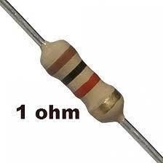

Fig.5: Resistor

LCD Module
LCD (Liquid Crystal Display) modules are indispensable components found in a wide array of electronic devices, prized for their low power consumption, superior visibility, and adaptability in presenting both textual and graphical information. They are available in various types tailored to suit different applications. Character LCDs, for instance, are adept at displaying text in a grid format, commonly utilized in straightforward devices such as digital meters and household appliances, often configured as 16x2 or 20x4. On the other hand, graphic LCDs offer the capability to exhibit images and custom characters, making them well-suited for more intricate applications like handheld gadgets and control interfaces, with popular resolutions including 128x64 or 240x128 pixels. Segment LCDs cater to fixed segment displays, apt for digital clocks, calculators, and similar devices necessitating numeric or simple alphanumeric displays. Meanwhile, TFT LCDs (Thin-Film Transistor) provide high-resolution displays with vivid color rendition, suitable for advanced applications like smartphones, tablets, and automotive dashboards.
Critical features of LCD modules encompass their resolution, determining the display's pixel or character capacity; backlight functionality, enhancing visibility in dimly lit conditions; viewing angle, which dictates the maximum angle from which the display remains legible, with wider angles preferred for user interfaces viewed from various perspectives; interface options such as parallel, SPI (Serial Peripheral Interface), and I2C (Inter-Integrated Circuit), facilitating connectivity with microcontrollers; power consumption, a defining characteristic with LCDs known for their energy efficiency, rendering them suitable for battery-operated devices; and operating temperature range, ensuring operational functionality across different environmental conditions, from consumer electronics to industrial settings.

Driving an LCD module typically entails employing a microcontroller to transmit signals for displaying requisite information. For instance, interfacing a character LCD with a microcontroller involves connecting power supply pins, control pins (RS - Register Select, RW - Read/Write, E - Enable), and data pins (D4 to D7 for a 4-bit interface) to the microcontroller’s GPIO (General Purpose Input/Output) pins. The initialization process encompasses setting the function mode (8- bit or 4-bit, number of lines, and font size), activating the display, setting the cursor, and clearing the display. Data transmission involves setting the RS pin to HIGH and the RW pin to LOW, followed by sending the data byte, while commands necessitate setting the RS pin to LOW and RW pin to LOW. An Arduino example employing the Liquid Crystal library elucidates this process, initializing interface pins, configuring the LCD’s columns and rows, and displaying messages or real-time data.
LCD modules find diverse applications across various industries. In consumer electronics, they serve to display information and status in appliances like microwaves, washing machines, and digital clocks. In industrial control systems, LCDs showcase sensor readings, machine status, and control menus. Medical devices rely on LCDs to provide precise, clear readings, notably in equipment like blood pressure monitors and glucose meters. In the automotive sector, TFT LCDs are instrumental in displaying critical information on vehicle dashboards. Portable devices such as GPS units, handheld games, and e-readers utilize graphic and TFT LCDs for their user interfaces. The ESP32 microcontroller platform, renowned for its robust features and cost-effectiveness, frequently integrates LCD modules. Boasting built-in Wi-Fi and Bluetooth capabilities, the ESP32 is apt for IoT applications and seamlessly integrates with LCDs to create advanced user interfaces. Supported by tools like the ESP-IDF (Expressive IoT Development Framework) and compatible with the Arduino IDE, the ESP32 development environment facilitates swift development and deployment of LCD module-related applications.

An active and growing community surrounding LCD modules and platforms like the ESP32 substantially contributes to their widespread adoption. Developers continually enrich the community with open-source libraries, tutorials, and forums, fostering troubleshooting and innovation through knowledge sharing. LCD modules' compatibility with various operating systems and real-time operating systems (RTOS), such as FreeRTOS, enables precise hardware resource management and real-time task execution, rendering them suitable for applications requiring deterministic performance, like audio processing, real-time data acquisition, and control systems.
Moreover, LCD modules boast robust security features, encompassing hardware encryption, secure boot, and flash encryption, ensuring data integrity at rest and during transmission, making them pivotal in security-sensitive IoT applications. Furthermore, their seamless integration with cloud platforms like AWS, Google Cloud, and Azure facilitates the development of scalable IoT solutions harnessing cloud computing resources for data analysis, machine learning, and remote management.
In educational settings, LCD modules serve as invaluable tools for teaching students about embedded systems, programming, and IoT concepts. Their affordability and user-friendly nature make them ideal for hands-on learning and experimentation, contributing to the cultivation of a new generation of engineers and developers.
In conclusion, LCD modules, with their advanced features, extensive connectivity options, energy efficiency, and strong community support, stand as versatile and widely utilized components in modern electronics. Whether in IoT, industrial automation, health monitoring, robotics, or education, LCD modules provide a robust platform for innovation and development.

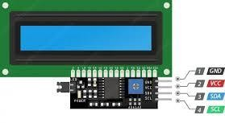

LED:
Fig.6: LCD Module

Light Emitting Diodes, commonly known as LEDs, are semiconductor devices that emit light when an electric current is applied. This technology has revolutionized illumination, finding applications in various fields due to its energy efficiency, durability, and versatility.
At the heart of an LED is a semiconductor material, typically composed of gallium arsenide, gallium phosphide, or other compounds. When electrons and holes (positively charged vacancies) recombine in this material, energy is released in the form of photons, creating light. Unlike traditional incandescent bulbs, which rely on heating a filament to produce light, LEDs operate on a fundamentally different principle, making them much more energy-efficient.
One key characteristic of LEDs is their ability to emit light in a specific colour range determined by the semiconductor materials used. By adjusting the composition and structure of these materials, manufacturers can produce LEDs that emit light across the visible spectrum. This capability makes LEDs ideal for various applications, from simple indicator lights to full-colour displays.
The efficiency of LEDs is a standout feature. Traditional incandescent bulbs waste a significant amount of energy as heat, whereas LEDs generate very little heat, directing most of the electrical energy into light production. This efficiency not only reduces energy consumption but also contributes to the extended lifespan of LEDs. The absence of a fragile filament, which can break

or burn out, enhances their durability.

LEDs have become ubiquitous in everyday life. They illuminate homes, offices, streets, and electronic devices.
Moreover, LEDs have made a substantial impact in the field of electronics. They are integral to the functioning of display technologies like LED-backlit LCD screens, providing vivid colours and high contrast ratios. LEDs also play a crucial role in optoelectronics, serving as light sources in fibre optic communication systems and optical sensors.
In recent years, advancements in LED technology have led to the development of smart lighting systems. These systems allow users to control the color, intensity, and even the direction of light through mobile apps or voice commands. This not only enhances user experience but also contributes to further energy savings by tailoring lighting to specific needs.
Beyond conventional lighting, LEDs have found applications in horticulture, where specific light spectra can be tailored to optimize plant growth. Additionally, they are utilized in automotive lighting, providing brighter and more energy-efficient headlights, brake lights, and interior lighting.
In conclusion, LED lights represent a transformative technology that has reshaped the lighting industry and influenced various other fields. Their energy efficiency, durability, and versatility have made them a go-to choice for diverse applications, from everyday lighting to advanced electronics. As technology continues to advance, LEDs are likely to play an even more significant role in shaping the future of illumination and beyond.
The fundamental principle behind LED operation is electroluminescence, a process where light is emitted as a result of the recombination of electrons and holes in a semiconductor material. The specific wavelength, or colour, of the emitted light is determined by the energy bandgap of the semiconductor. This unique characteristic allows manufacturers to engineer LEDs that emit

light in a wide range of colours, from the visible spectrum to ultraviolet and infrared. Semiconductor materials play a crucial role in defining the performance of LEDs. Gallium nitride (Gann) has become a dominant material for blue and green LEDs, which are essential for producing white light in combination with phosphor coatings. The development of blue LEDs in the 1990s marked a significant breakthrough, as it enabled the creation of white light by combining blue LEDs with phosphors that emit yellow light. This approach, known as phosphor conversion, is widely used in the production of white LEDs.
LEDs offer remarkable efficiency compared to traditional lighting technologies. Incandescent bulbs convert only about 5% of the energy they receive into visible light, while the rest is emitted as heat. On the other hand, LEDs can convert more than 90% of their energy into light. This efficiency not only reduces electricity consumption but also contributes to a longer operational life, as less heat means less stress on the semiconductor components.
The lifespan of LEDs is a key factor in their widespread adoption. Traditional incandescent bulbs typically last around 1,000 hours, while compact fluorescent lamps (CFLs) may last up to 10,000 hours. In contrast, LEDs can last anywhere from 25,000 to 100,000 hours or more, depending on factors such as temperature and current. This longevity translates into fewer replacements, reduced maintenance costs, and a smaller environmental footprint.
Beyond their efficiency and longevity, LEDs offer precise control over light output. Traditional lighting sources often rely on external reflectors or diffusers to control the direction and spread of light. In contrast, LEDs inherently emit light in a specific direction, allowing for more focused and directional illumination. This characteristic is particularly advantageous in applications such as automotive headlights, street lighting, and spotlights.

The versatility of LED technology extends to its adaptability in various environments. LEDs can operate efficiently in a wide range of temperatures, making them suitable for both indoor and outdoor use. They also exhibit rapid response times, making them ideal for applications that require instant illumination, such as brake lights in vehicles.
In recent years, the integration of LEDs with smart technology has opened up new possibilities in lighting design and control. Smart LED lighting systems enable users to adjust colour temperatures, brightness levels, and even create dynamic lighting scenes through smartphone apps or voice-activated assistants. This not only enhances the aesthetic aspects of lighting but also contributes to energy conservation by allowing users to tailor lighting to specific needs and scenarios.
In conclusion, the ongoing advancements in LED technology continue to redefine the landscape of illumination. From their efficient and long-lasting performance to their adaptability in various applications, LEDs have become a cornerstone in modern lighting solutions. As research and development in semiconductor materials progress, we can expect further innovations that will shape the future of lighting technology and its integration into diverse fields.
The LED lights are available at prices ranging from a minimum of 4 rupees to a maximum of 5 rupees and some Specifications.
- Operating Voltage: Typically around 3.3-5 volts, suitable for use with Arduino Uno's 5Voutput pins.
- Current Consumption: Usually a few milliamps per LED, depending on brightness andcolour.
- Colour: LEDs can emit various colours such as red, green, blue, yellow, and white.

- Size and Form Factor: Common sizes include 3mm and 5mm diameter LEDs, as well as surface-mount (SMD) variants.
- Forward Voltage Drop: Typically around 1.8-3.3 volts depending on the colour of the LED.
- Brightness: Measured in lumens or mill candela (mcd), indicating the intensity of light emitted.
- Viewing Angle: Specifies the angular range over which the LED emits light effectively.

- Lifetime: LEDs generally have a long lifespan, often tens of thousands of hours.

Sources: You can purchase LED lights from a variety of sources, including local hardware stores, electronics retailers, online marketplaces such as Amazon or Flipkart, and specialized lighting stores. When buying LED lights, consider factors such as the desired brightness (measured in lumens), colour temperature, energy efficiency (look for Energy Star certification or BEE ratings in India), and compatibility with any existing fixtures or dimmer switches you may have. It's also advisable to read customer reviews and compare prices before making a purchase to ensure you're getting the best value for your money.

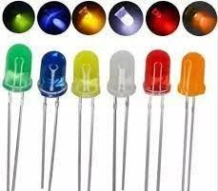
Fig.7: LED

Breadboard:
A breadboard is a crucial tool in the realm of electronics, serving as a prototyping platform for constructing and testing circuits without the need for soldering. Its design enables engineers, hobbyists, and students to experiment with various components and configurations rapidly, fostering a flexible and iterative approach to circuit development.
At its core, a breadboard consists of a rectangular board with an array of interconnected metal clips arranged in a grid. These clips, often made of springy metal, allow for the insertion and connection of electronic components. The board typically features rows and columns labelled with alphanumeric coordinates, aiding in component placement and circuit organization.
The most common type of breadboard follows the International Electronics Commission (IEC) standard, featuring two main sections: the terminal strips and the bus strips. The terminal strips run vertically along the sides of the board, each containing multiple interconnected clips. These strips serve as the primary points for connecting components, such as resistors, capacitors, and integrated circuits.
In contrast, the bus strips run horizontally across the breadboard, usually divided into sections. They provide a means to distribute power and ground throughout the circuit. Often, one section is dedicated to positive voltage (Vcc), while another is reserved for ground (GND). This arrangement facilitates the creation of organized and neat circuits, as it aligns with the typical power distribution requirements in electronic designs.
Breadboards come in various sizes, accommodating projects of different complexities. Larger breadboards offer more space for components and larger circuits, while smaller ones are suitable for simple experiments.

Regardless of size, the fundamental principle remains the same – the ability to create temporary connections between components through the interconnected clips without the need for soldering.
One of the key advantages of breadboards is their reusability. Since components are simply inserted into the clips, they can be easily removed and repositioned, allowing for quick modifications and iterations. This feature is especially valuable during the prototyping phase of a project, where frequent adjustments and testing are necessary to refine the circuit design.
While breadboards excel in rapid prototyping, it is important to note that they have limitations. High-frequency circuits, circuits dealing with high currents, or those requiring precise impedance matching may experience challenges on a breadboard due to parasitic capacitance and inductance inherent in the design. In such cases, more advanced prototyping techniques or custom PCBs (Printed Circuit Boards) may be necessary for accurate representation and testing.
In conclusion, the breadboard stands as an indispensable tool in the electronics enthusiast's toolkit. Its versatility, ease of use, and reusability make it a fundamental component of the prototyping process. Whether used for educational purposes, hobbyist projects, or professional development, the breadboard provides a platform for experimenting with electronic circuits, fostering innovation and creativity in the field of electronics.
Certainly! A breadboard's intricate design and functionality contribute significantly to its widespread use in electronics prototyping. The primary purpose of a breadboard is to facilitate the construction and testing of circuits without the permanent connections imposed by soldering. Let's delve deeper into some key aspects of breadboards:

Structure and Configuration:

A typical breadboard features a grid of holes, and each hole corresponds to a metal clip beneath the surface. The clips are arranged in rows and columns, making it easy to organize and connect components. The rows are often labelled with numbers, while the columns are labelled with letters, providing a coordinate system for reference.

Terminal Strips:

The vertical strips along the sides of the breadboard are known as terminal strips. These strips consist of interconnected clips and are primarily used for component placement. Components with two or more leads, such as resistors and integrated circuits, can be inserted into these strips, allowing for easy connections.

Bus Strips:

The horizontal strips that run across the breadboard are called bus strips. They are typically divided into sections, each serving a specific purpose. One section may be designated for positive voltage (Vcc), another for ground (GND), and additional sections for other power rails. These bus strips facilitate the distribution of power throughout the circuit, simplifying the wiring process.

Reusable Prototyping:

One of the breadboard's standout features is its reusability. Components can be effortlessly plugged in and removed, making it an ideal platform for iterative design. This characteristic is particularly valuable during the experimentation phase, where designers often need to make rapid changes and test various configurations.

Component Placement:

Understanding how to place components on a breadboard is crucial. Components are inserted such that their leads make contact with the metal clips beneath the holes. Proper alignment ensures a functional circuit. Many breadboards include a central gap that divides the board into two halves. This gap is not just for aesthetics but serves as a convenient way to create separate circuits on each side.

Limitations:
While breadboards are versatile, they do have limitations. High-frequency circuits may suffer from parasitic capacitance and inductance, affecting signal integrity. Additionally, the contacts in the clips introduce some resistance, so high-precision applications may require alternative prototyping methods or custom PCBs.

Educational Significance:
Breadboards play a vital role in electronics education. They provide a hands-on experience for students to grasp fundamental concepts such as circuit design, component functionality, and the flow of electricity. The tactile nature of bread boarding enhances learning and encourages experimentation.

Evolution and Variations:

Over time, variations of breadboards have emerged, catering to specific needs. Mini breadboards, for example, are compact and suitable for small projects. Solderless breadboards with built-in power supplies and additional features offer enhanced convenience for certain applications.
In essence, the breadboard represents more than just a prototyping tool; it symbolizes the bridge between theoretical understanding and practical implementation in the field of electronics.

The breadboard is available at prices ranging from 59 to 169 rupees, making it an affordable and versatile tool for prototyping electronic circuits with an Arduino Uno or other compatible microcontroller boards and some Specifications.
        - Compatibility: The breadboard is compatible with Arduino Uno and other similar microcontroller boards.
        - Connection Points: It provides a convenient platform for prototyping circuits and creatingtemporary connections between components.
        - Terminal Strips: The breadboard typically consists of terminal strips arranged in a gridpattern, allowing for easy insertion and connection of electronic components.
        - Power Rails: It features power rails on both sides, typically labelled as VCC (power) andGND (ground), which can be used to distribute power to the connected components.
        - Versatility: The breadboard supports various types of electronic components, includingresistors, capacitors, LEDs, sensors, and jumper wires.
        - Reusability: Components can be easily inserted and removed from the breadboard, making it reusable for multiple prototyping projects.
        - Compact Design: Its compact size makes it suitable for small-scale projects and experimentation.
        - No Soldering Required: Since it relies on spring-loaded connections, no soldering isrequired, allowing for quick and hassle-free circuit prototyping.
        - Stability: It provides a stable platform for testing and debugging electronic circuits beforesoldering them onto a permanent PCB (Printed Circuit Board).
          - Educational Tool: The breadboard is widely used in electronics education and workshopsto teach basic circuit design and experimentation techniques.

Sources:

You can purchase breadboards from various sources, including electronics stores, online retailers like Amazon or eBay, and specialized hobbyist shops. Additionally, local electronics markets or stores may carry them.
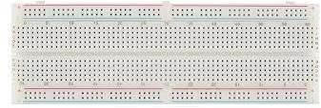

Fig.8: Breadboard

Jumpers Wires:

Jumper wires are essential components in electronics and electrical circuits, serving a fundamental role in establishing connections between various components ona breadboard or a circuit board. These wires, often composed of copper or aluminium, are insulated to prevent short circuits and ensure the flow of electrical signals without interference.
In the realm of electronics prototyping and experimentation, jumper wires act as flexible conductors that link different points on a circuit. They allow engineers, hobbyists, and students to quickly and easily create temporary connections, facilitating the testing and validation of circuit designs. The term "jumper" originates from the idea that these wires can "jump" from one point to another, creating a bridge for the electrical current.

These wires come in various lengths and colours, aiding in the organization and identification of connections within a circuit. Longer jumper wires might be used to span larger distances on a breadboard, while shorter ones are employed for more localized connections. The colour coding helps distinguish different signal paths or components, reducing the risk of errors during circuit assembly.
The insulation of jumper wires is crucial in preventing unintentional short circuits. Most jumper wires are covered with a thin layer of plastic or rubber, isolating the conducting core. This insulation ensures that the current flows only along the intended path, preventing electrical interference and maintaining the integrity of the circuit.
Jumper wires are particularly valuable in educational settings, where they provide a hands-on approach to learning about electrical circuits. Students can experiment with different configurations, easily modifying connections to observe the impact on circuit behavior. This practical experience enhances understanding and promotes problem-solving skills in the field of electronics.
In addition to their educational and prototyping uses, jumper wires play a vital role in troubleshooting circuits. Engineers and technicians often employ these wires to isolate and test specific sections of a circuit, helping identify faulty components or connections. The flexibility
and simplicity of jumper wires make them indispensable tools for diagnosing issues and ensuring the proper functioning of electronic systems.

As technology advances, the design and materials of jumper wires continue to evolve. Some wires feature connectors on one or both ends, simplifying the process of connecting to various components. Additionally, advancements in insulation materials enhance the durability and safety of these wires, making them more resilient to environmental factors and wear.
In conclusion, jumper wires are integral to the world of electronics, providing a versatile means of creating connections in circuits. Their flexibility, colour coding, and insulation make them invaluable tools for prototyping, education, and troubleshooting. As electronic systems become increasingly complex, the importance of these simple yet essential components remains paramount in facilitating innovation and progress in the field.
Jumper wires, in the intricate landscape of electronics, serve as the unsung heroes bridging the gap between theoretical circuit designs and tangible prototypes. Composed predominantly of conductive materials such as copper or aluminum, these wires embody versatility in their ability to establish temporary connections between various points on a circuit. The very term "jumper" encapsulates the essence of these wires, effortlessly leaping from one component to another, facilitating the smooth flow of electrical current.
Within the realm of electronics prototyping, where experimentation is key, jumper wires emerge as essential tools. Their primary purpose lies in enabling engineers, hobbyists, and students to swiftly construct and modify circuits on breadboards or circuit boards. This agile adaptability is particularly valuable during the iterative process of design, allowing for rapid testing and refinement without the need for permanent soldered connections.

The physical attributes of jumper wires contribute significantly to their utility. These wires come in diverse lengths, catering to the specific spatial requirements of a circuit. Longer jumper wires may traverse the expanse of a breadboard, connecting components situated farther apart, while shorter ones delicately link adjacent elements. This flexibility in length, combined with a spectrum of colours, not only accommodates the spatial intricacies of circuitry but also aids in organizing and identifying different signal paths or components.
The insulation enveloping jumper wires is a critical aspect that ensures their functionality and safety. Typically crafted from materials like plastic or rubber, this insulation serves the dual purpose of preventing short circuits and safeguarding against electrical interference. By encapsulating the conductive core, the insulation directs the electrical current along the intended path, preserving the integrity of the circuit and preventing unintended crosstalk or disruptions.
In educational contexts, jumper wires become invaluable tools for hands-on learning. Aspiring engineers and students can engage in practical experimentation, manipulating connections to observe the real-time impact on circuit behavior. This tactile approach enhances comprehension, allowing individuals to apply theoretical knowledge to tangible outcomes and fostering a deeper understanding of electronics principles.
Beyond educational settings, jumper wires play a pivotal role in the diagnostic phase of electronic systems. Engineers and technicians employ these wires to selectively isolate and test specific sections of a circuit. This meticulous approach aids in identifying faulty components, loose connections, or other issues that may impede the proper functioning of the overall system. The ease with which jumper wires can be inserted, rearranged, and removed makes them indispensable for troubleshooting and refining electronic designs.

As technology advances, so does the design and functionality of jumper wires. Some variants now come equipped with connectors on one or both ends, streamlining the connection process and reducing the risk of accidental dislodgment. Advances in insulation materials enhance durability, making jumper wires more resistant to environmental factors and physical wear.
In the grand tapestry of electronic innovation, jumper wires emerge as unassuming yet vital components. Their flexibility, adaptability, and simplicity make them essential facilitators of progress, enabling the seamless transition from conceptualization to realization in the dynamic field of electronics.
Jumper’s wires, ranging in price from 70 to 179 rupees, offer a cost-effective solution for creating connections between components on a breadboard or between various modules in electronic projects and some Specifications.
- Length: Typically available in various lengths ranging from 10cm to 30cm.
- Wire Gauge: Commonly constructed with 22 AWG (American Wire Gauge) or 24 AWG stranded wire.
- Conductor Material: Often made of tinned copper for excellent conductivity and corrosion resistance.
- Insulation Material: Typically insulated with PVC (Polyvinyl Chloride) or silicone for flexibility and durability.
- Connector Types: Available with various connector types such as male-to-male, male-to- female, and female-to-female connectors.
- Colour Coding: Often color-coded for easy identification and organization of connections.

- Operating Temperature: Can withstand temperatures ranging from -20°C to 80°C, depending on the insulation material.
- Maximum Current Rating: Typically rated for currents up to 2A or 3A, depending on the wire gauge and quality.
- Compatibility: Compatible with various prototyping platforms such as Arduino, Raspberry Pi, and breadboards.
- Packaging: Sold in packs containing multiple wires of different colours for convenient use in electronic projects.
Sources: Jumpers wires can be sourced from various electronics stores, hobbyist shops, or online marketplaces such as Amazon, eBay, or Ali Express. These wires are commonly used for prototyping and connecting electronic components on breadboards or PCBs. They come in various lengths, gauges, and connector types (such as male-to-male, male-to-female, or female- to-female) to suit different project requirements.
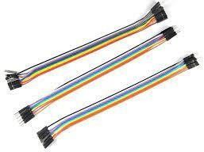

Fig.9: Jumper Wires

USB Type B Cable:
The USB Type-B cable is an essential component in electronic connectivity, widely used for interfacing peripherals such as printers, scanners, and microcontroller boards with host devices like computers. This cable adheres to the Universal Serial Bus (USB) standard, ensuring a standardized interface for data transfer and power supply between devices.
It features two distinct connectors: a USB Type-A connector, which is flat and rectangular, commonly found on computers, laptops, USB hubs, and power adapters; and a USB Type-B connector, typically square with beveled corners or trapezoidal, used for connecting to peripheral devices. The cable comprises four primary conductors: VCC and GND for power supply, and D+ and D- for bidirectional data transfer, essential for tasks such as uploading data, debugging, and device interaction.
Supporting data transfer rates up to 480 megabits per second (Mbps) under the USB 2.0 standard, the cable is suitable for most applications, despite newer standards offering higher speeds. Physically, the cable typically ranges from 1 to 2 meters in length, constructed with high-quality copper conductors for efficient data transfer and durability, and shielded to minimize electromagnetic interference. Its robust construction, including reinforced connectors and strain relief, ensures longevity.
The USB Type-B cable is compatible with a wide range of devices and is particularly crucial for connecting microcontroller boards like Arduino to computers for programming and power supply. The cable simplifies the setup process by eliminating the need for separate power sources, making it an efficient and practical choice for a variety of projects. Additionally, the USB Type-B cable is instrumental in establishing a reliable communication link between the host device and peripherals, ensuring smooth and uninterrupted data flow necessary for the
functioning of various applications.

In terms of compliance, the USB Type-B cable adheres to USB 2.0 specifications, ensuring compatibility and performance standards that meet industry requirements. Furthermore, it meets Restriction of Hazardous Substances (RoHS) regulations, highlighting its commitment to safety and environmental protection. This compliance ensures that the cable is free from hazardous materials, making it safe for use in diverse environments.
The availability of USB Type-B cables through various online and local retailers adds to their convenience and accessibility. Online platforms like Amazon, Spark Fun, Ad fruit, and the official Arduino website offer a wide selection of USB Type-B cables, catering to different lengths and specifications to meet various user needs. Local electronics and hobbyist shops also stock these cables, providing an immediate solution for those who prefer in-person purchases.
In professional settings, the USB Type-B cable is vital for the seamless operation of office equipment such as printers and scanners, facilitating quick and reliable data transfer between computers and peripherals. In educational and hobbyist environments, the cable is indispensable for projects involving microcontroller boards like Arduino, enabling users to program, test, and interact with their devices effortlessly.
Furthermore, the USB Type-B cable's role extends to industrial applications where reliable data transfer and power delivery are critical. Its robust construction and shielding make it suitable for environments where electromagnetic interference is a concern, ensuring that data integrity is maintained even in challenging conditions.
An additional benefit of the USB Type-B cable is its ability to charge devices while facilitating data transfer. This dual functionality is particularly beneficial for devices that require constant power, such as external hard drives and certain microcontroller boards. The convenience of simultaneous data and power transfer simplifies the user experience, reducing the number of cables needed for different functions.

The longevity of the USB Type-B cable is another significant advantage. The robust construction of the connectors, along with the strain relief design, prevents wear and tear from frequent plugging and unplugging. This durability is crucial for environments where the cable will be used regularly, such as in schools, offices, and workshops.
The USB Type-B cable's versatility extends to its use in various custom projects and DIY electronics. Hobbyists and engineers often rely on this cable for prototyping and developing new devices, appreciating its reliable performance and ease of use. The standardized nature of the USB Type-B connector also ensures compatibility across different projects and components, making it a staple in the toolkit of any electronics enthusiast.
In summary, the USB Type-B cable's standardized design, durability, and reliable performance make it a vital tool for ensuring efficient and stable connections in numerous applications. Its role in facilitating data transfer and power supply underscores its importance in the broader context of electronic device connectivity. The combination of its technical specifications, physical durability, and compliance with safety standards positions the USB Type-B cable as a trusted and essential component in both every day and specialized electronic setups. Its availability through various retail channels and its applicability across multiple domains further solidify its status as a fundamental element in modern electronic infrastructure.

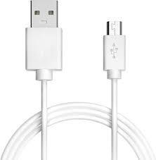

Fig.10: USB Type B Cable

4.2 Economic Feasibility

PRODUCT | PRICE
ESP 32 | 500
FORCE SENSOR | 350
LCD MODULE | 150
USB CABLE | 120
JUMPER WIRE | 70
BREADBOARD | 60
LED LIGHT | 4
RESISTOR | 3

Table.1: Economic Feasibility

Chapter 5 Methodology
5.1 Methodology
The proposed system is designed to assist paralyzed patients in effectively conveying their instructions or needs. It consists of several components working together seamlessly to facilitate communication between the patient and caregiver.
At the core of the system is a force sensor, which is connected to a microcontroller board. The microcontroller board is programmed using the Arduino IDE compiler and serves as the controller for all main and sub-equipment within the system. Additionally, a Wi-Fi module isintegrated with the microcontroller board, enabling communication functionalities.
The primary objective of the system is to identify simple finger movements made by the patient to express their requirements. Sensors attached to the patient's body measure the acceleration, gestures, or movements of the fingers. These sensors relay input signals to the microcontroller, which then processes the data.
The microcontroller maps the input voltages received from the sensors and assigns specific ranges for each finger movement. Predefined messages corresponding to basic requirements and emergencies are stored within the system for each sensor movement range. When a movement or gesture is detected by the sensors, the microcontroller retrieves the corresponding message from its memory.
Once the message is retrieved, the Wi-Fi module connected to the microcontroller is activated. It sends out messages containing the desired information to the caregiver, alerting them to the patient's needs or emergencies. Simultaneously, the conveyed messages are displayed on an LCD screen, making it easier for the patient to understand and confirm the communication.
One of the key advantages of this system is its adaptability to the severity of the patient's condition. It can be adjusted and customized based on the individual needs and capabilities of the patient. Additionally, the system is designed to be portable and accessible from anywhere, ensuring the patient's comfort and convenience.

In summary, the proposed system offers a comprehensive solution for paralyzed patients to effectively communicate their instructions or needs, thereby enhancing their quality of life and overall care...

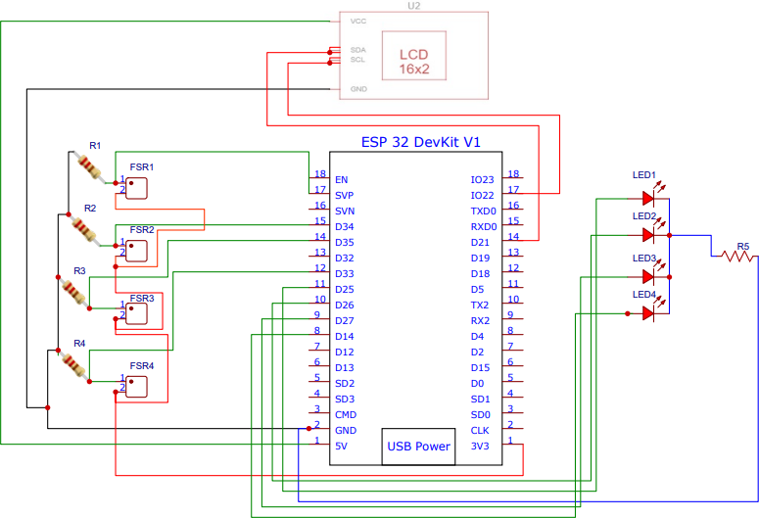

Fig.11: Schematic diagram of IoT MedTech

Chapter 6 Results and Discussion

  - Prototype Model:
IoT MedTech operates as follows: The patient starts the communication by moving the fingers on the force sensor of the device. When the sensor detects movement or gestures, it sends input signals to a microcontroller, which then reads and pre-processes the data, recognizing patterns. These patterns are mapped to predefined messages related to basic needs and emergencies within the sensor's range of movement. The microcontroller, equipped with a GSM module, transmits these messages, and the LCD screen displays as shown in below Screen Shots the information for the patient's understanding.

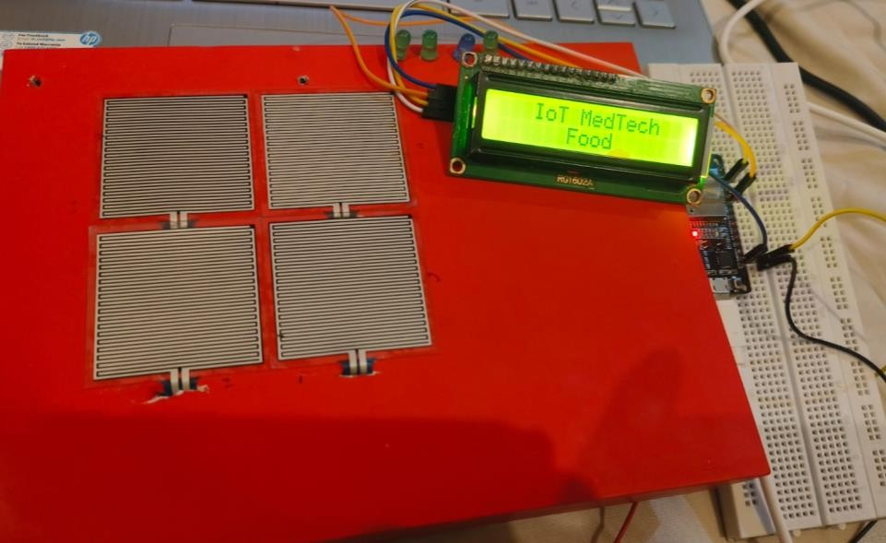
Fig.12: Prototype Model

Comparative Study

    - Comparative Analysis based on cost

S. No. | Existing Products | Min. Product Cost  (In Rupees) | Max. Product Cost  (In Rupees)
1 | Reverse Paralysis Technology | 5,82,339.45 | 2,49,574.05
2 | Robotic Arm | 16,63,827 | 66,55,308
3 | Mind Controlled Bionic Arm | 3,07,724 | 6,65,530.80
4 | Eye-Blink | 80,000 | 1,25,000
5 | Smart Gloves | 18,250 | 50,000
6 | IoT MedTech | 4203 | 6736
Table 2: Comparative Analysis based on cost

BCI Technology:

Also known as reversing paralysis technology that is used for assisting the paralyzed patient for their day-to-day activities who have completely lost their movement. Using BCI technology devices like exoskeletons, mind-controlled prosthetics are made to help these kinds of people. BCI analyzes brain patterns of the individuals to control the movements of body parts. This is the most expensive technology available in market which costs ranging from 20,000$ to 5, 00, 000$. (Sources: research gate, Smithsonian Magazine, [16]).Due to high cost this is not accessible for all those who really needs in their life especially for poor people.

Benjamin Choi’s Robotic Arm:
In 2020, Choi proposed a robotic arm that uses AI algorithms to analyze the brain pattern for disabled person who can't move their body parts, meant to help them in their everyday tasks. The

system works by picking up signals from the brain using a special sensor called EEG to control how the arm moves. But the problem arises here that first it needs to analyze the brain patterns which is time taking process, accuracy increases over time and creating dataset is complex. (Source Smithsonian magazine).

Smart Gloves
These gloves are made for the quiet people and those who can’t move much. It has sensors that collect data on hand movements to understand specific signs and words. Paralyzed patients can wear these gloves to control things at home by moving their fingers and also they can convey their basic requirements through finger movement to the care taker. These smart gloves are ranging from 20,000 to 60,000 as listed on Amazon e-commerce website. These smart gloves has limited instructions and sometime response is not proper.
Sources (Amazon.in, [17], [18], [19])

IOT - MedTech (2023):
We proposed IoT MedTech device - an IoT based system that enables them to convey their basic requirements and emergency messages simply by moving their finger to display the desired message, at minimal cost. The IoT MedTech ranges from rupees 4,203 to rupees 6,736.Unlike BCI or reverse paralysis technology there is no requirement of surgery for prosthetics body parts or no need to analyses the brain pattern or signal. It clearly tackles the problems of retina analysis technology i.e. it is completely suitable for tetraplegia patient which is not possible in retina analysis treatment. Also solve the limited instruction problem of smart gloves technology, in this device number of instruction can be adjusted based on the patient requirement. The IoT MedTech provides precise result and took minimal time to process. IoT MedTech is simple
, handy, affordable easy to use. Providing an innovative solutions to paralyzed patient to make their life easier

Comparative Analysis based on key features and technology

Ref | Year | IoT Devices | Components
[19] | 2016 | Smart Gloves | Flex Sensor, Inertial Measurement Unit(IMU)
[20] | 2017 | Eye-Blink | TCRT 5000
[21] | 2017 | Hybrid Wheel Chair | BNO-055 Module, ARM Cortex M3
[22] | 2018 | Fitness Tracker | LM-35 Temperature Sensor, Heartbeat Sensor, Eye-Blink Sensor, Accelerometer Sensor
[18] | 2018 | Sensor Gloves | LM-35, Flex Sensor, Voice Processor(APR33A3)
[17] | 2019 | Gloves | Flex Sensor
[23] | 2019 | Fitness Tracker | Heart-Pulse Sensor, Arduino UNO, Raspberry-pi
[24] | 2019 | Eye-Com | ADXL335
[16] | 2020 | Adaptive & Flexible Brain Energized Full Body Exoskeleton | Electroencephalogram(EEG)

Table 3: Comparative Analyses on Key Features

Technology | Distinct Features
Brain-Controlled Exoskeleton | Controlled by brain signals (EEG), enabling hands-free operation.  Assists in daily activities by translating brain signals into physical movement.  Requires training for proper use due to its advanced control mechanism  Integrates with IoT for enhanced control and functionality.  |
Better Wheelchairs | Utilizes sensors to monitor vital health parameters like temperature, heart rate, and movement  Provides remote patient monitoring, allowing caregivers to track patient well-being from a distance.  Automated system that continuously monitors patient health, sending alerts in case of abnormalities  Integration with GSM modules and IoT facilitates real-time data transmission to caregivers. |
Blink Sensor for Home Appliances | Activated by eye blinks, allowing paralyzed individuals to control home appliances independently  Simplifies home appliance control without the need for physical assistance  Consists of embedded electronics like the TCRT 5000 sensor, Bluetooth, and Arduino microcontroller for connectivity  Enables easy operation of appliances without relying on physical or human help.
Smart Gloves for Sign  Language | - Recognizes hand and finger movements to translate sign language into spoken words. |  Facilitates communication for individuals using sign

Smart Gloves for Sign Language | language, improving accessibility  Equipped with flexible sensors for accurate recognition of finger movements  Offers an intuitive interface for converting sign language gestures into speech. |

Table 4: Comparative Analysis on Technology

Chapter 7

SCREEN SHOTS
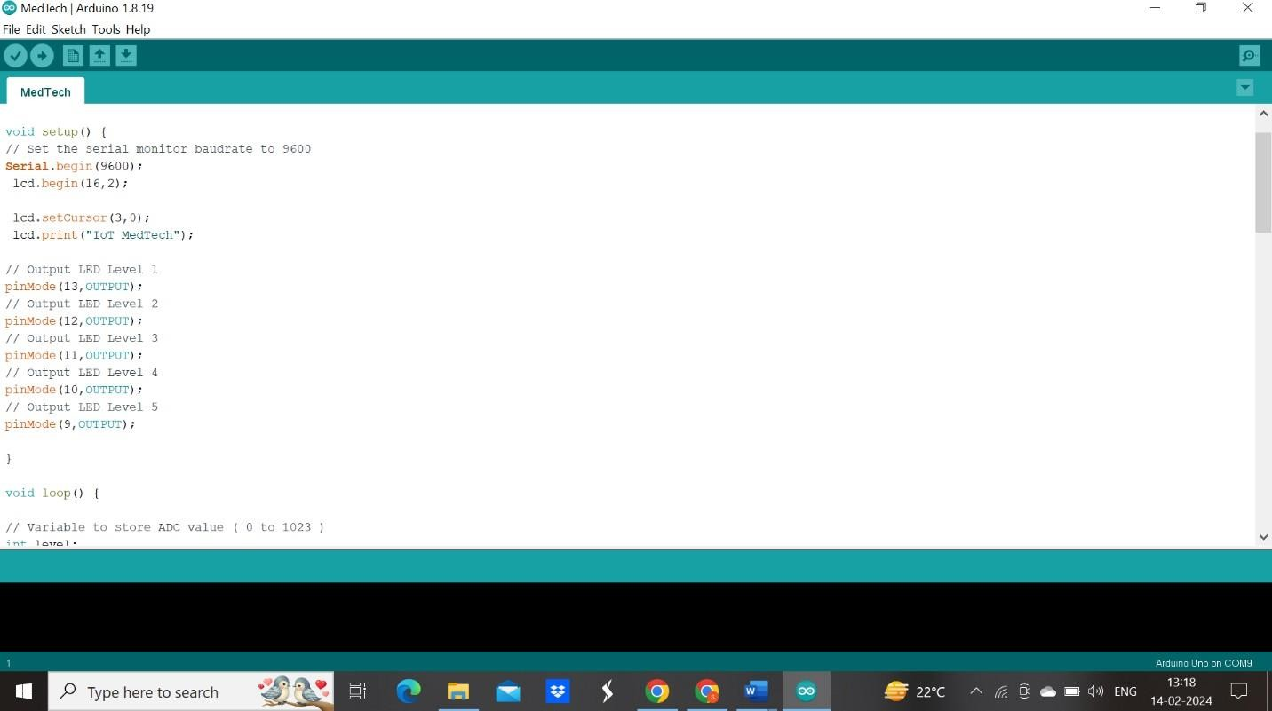
Fig.13: Screenshot 1
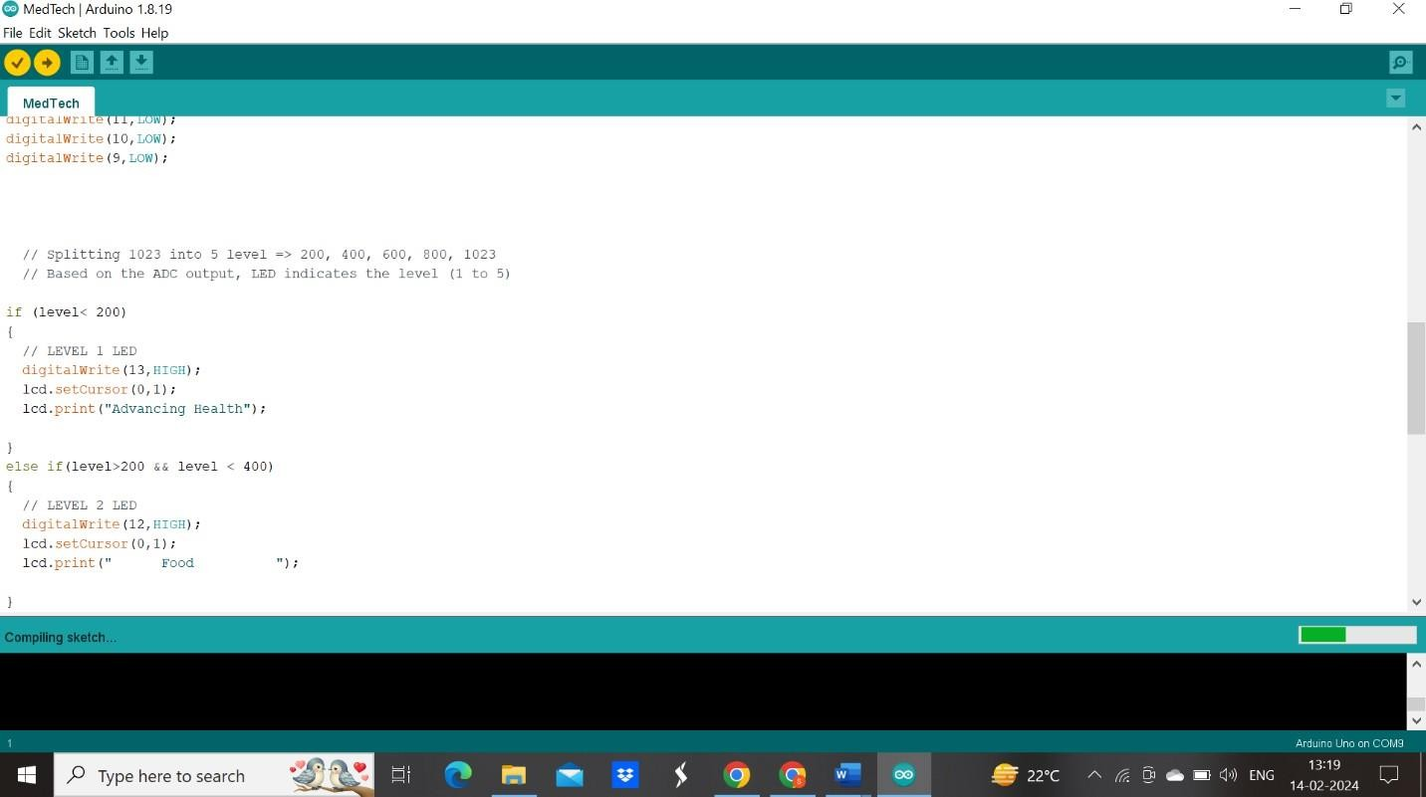
Fig.14: Screenshot 2

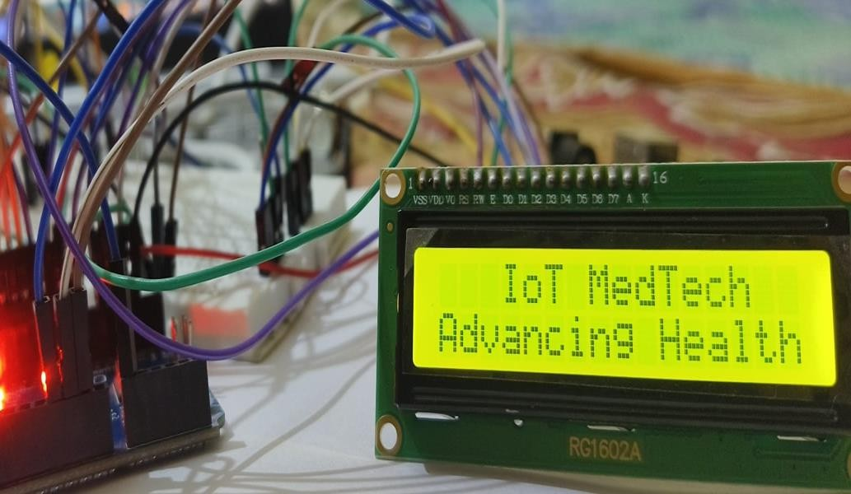

Fig. 15: IoT MedTech Advancing Healthcare

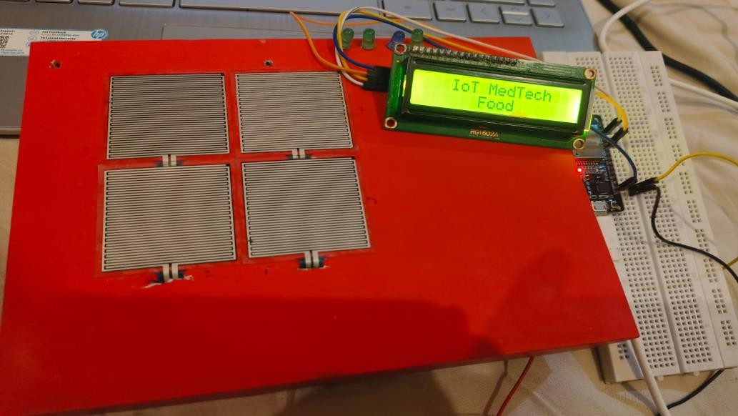

Fig. 16: Food Message

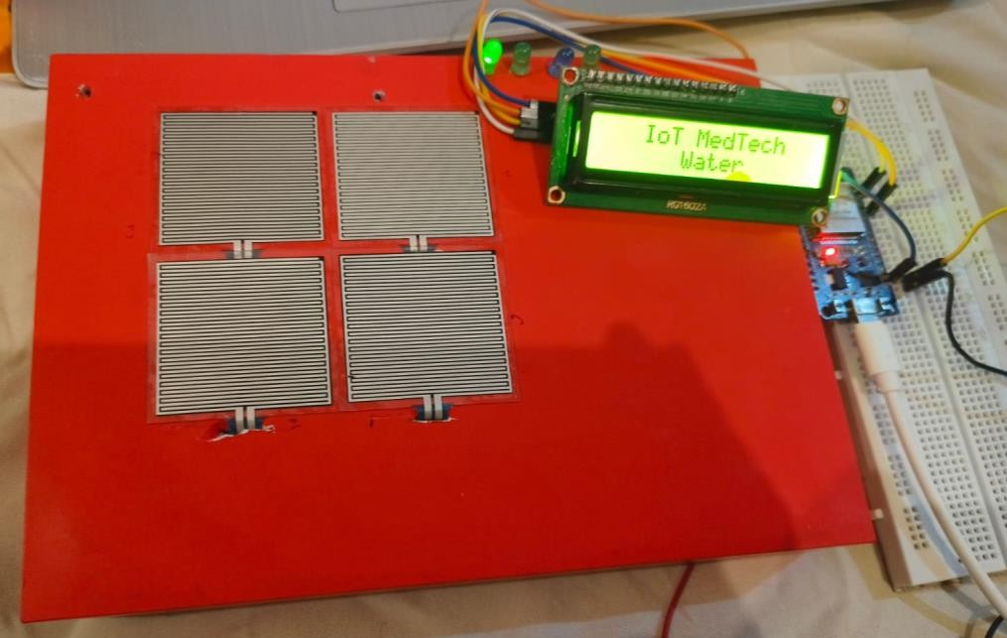

Fig. 17: Water Message
Fig. 1: Emergency Message

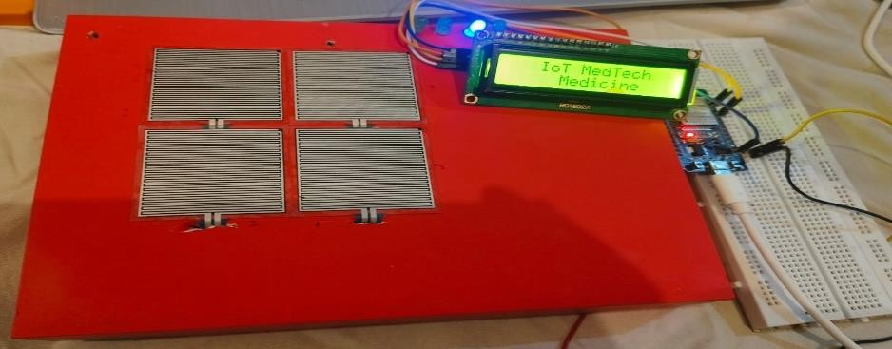

Fig. 18: Medicine Message

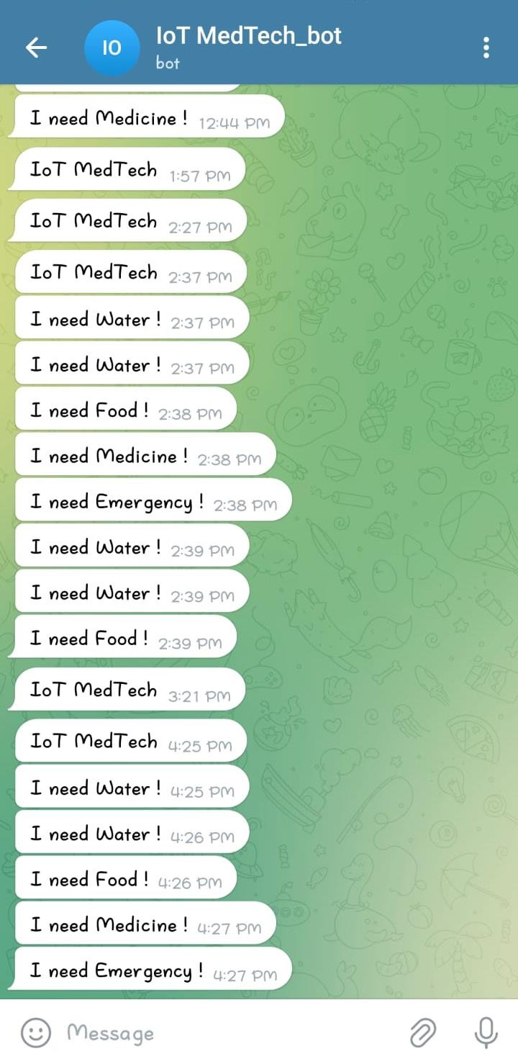

Fig. 19: Telegram Bot

Chapter 8
Future Scope and Conclusion

The proposed IoT MedTech aims to minimize the gaps between those people who somehow lost the ability of both moving and speaking (e.g., partial paralysis, quadriplegia, stroke, Parkinson, old age, people in ICUs, etc.), and find hard time in communication others. Existing solution include Brain Computer Interface (BCI) systems, exoskeletons and eye status monitoring. But, the devices using these technologies are expensive, sophisticated, and put an additional burden on the patient and also communication is not effective.
The proposed solution IoT MedTech assist in establishing a communication medium between patient and care giver where the patient is provided with a force sensor embedded device. The patient moves his/her finger on the device and based on the pattern of movements, the information is interpreted and conveyed to the care giver.
IoT MedTech helps these patients communicate their needs and emergencies, making care giving more efficient. This approach enhances the well-being of people with these kinds of disabilities, improving their quality of life.

REFERENCES
- Mohana, M., Priyadharshini, S., Sowmiya, N., & Devi, G. P. (2020). An IOT based automated communication system for paralyzed patients using simple hand gestures. European Journal of Molecular & Clinical Medicine, 7(4), 2681-2686.
- Mohammad Monirujjaman Khan et al., "IoT-Based Health Monitoring System Development and Analysis," Security and Communication Networks, vol. 2022, 2022.
- D. Shiva Rama Krishnan et al., "An IoT Based Patient Health Monitoring System," 2018 International Conference on Advances in Computing and Communication Engineering (ICACCE-2018), 2018.
- Sushmitha. J et al., "Patient Medical Check-up Using Webapp and IoT," SSRG International Journal of Computer Science and Engineering, vol. 5, no. 8, pp. 15-18, 2018.
- Shahanim Mohamad Hadis et al., "IoT Based Patient Monitoring System Using Sensors to Detect, Analyse and Monitor Two Primary Vital Signs," Journal of Physics: Conference Series, vol. 1535, pp. 1-11, 2020.
- Richa et al., "An IoT Based Health Monitoring System Using Arduino Uno," International Journal of Engineering Research & Technology (IJERT), vol. 10, no. 03, 2021
- Mohammad Monirujjaman Khan et al., “IoT-Based Smart Health Monitoring System for Covid-19 Patients,” Computational and Mathematical Methods in Medicine, vol. 2021, 2021.
- Suliman Abdulmalek et al., "IoT-Based Healthcare-Monitoring System Towards Improving Quality of Life: A Review," Healthcare, vol. 10, no. 10, 1993.
- Rohith, and K.Pavithra, "IoT Based Patient Health Monitoring System," International Research Journal of Modernization in Engineering Technology and Science.
- Fezari, M., & Al Dahoud, A. (2018). Integrated development environment “IDE” for Arduino. WSN applications, 1-12.
- M Mohana, S Priyadharshini, N Sowmiya, GP Devi - European Journal of Molecular & Clinical Medicine, 2020.

- S. Sengan, O. I. Khalaf, S. Priyadarsini, D. K. Sharma, K. Amarendra, and A. A. Hamad, “Smart healthcare security device on medical IoT using Raspberry Pi,” International Journal of Reliable and Quality E-Healthcare, vol. 11, no. 3, pp. 1–11, 2021.

- H. Zhao, P.-L. Chen, S. Khan, and O. I. Khalafe, “Research on the optimization of the management process on internet of things (IoT) for electronic market,” The Electronic Library, vol. 39, no. 4, pp. 526–538, 2021.

- A. Kotevski, N. Koceska, and S. Koceski, “E-health monitoring system,” in Proceedings of the International Conference on Applied Internet and Information Technologies, pp. 259–265, Bitola, Macedonia, 2016.

- N. S. M Hadis, M. N. Amirnazarullah, M. M. Jafri, and S. Abdullah, “IoT based patient monitoring system using sensors to detect, analyse and monitor two primary vital signs,” Journal of Physics: Conference Series, vol. 1535, Article ID 012004, pp. 1–12, 2020.

- Jacob, S., Alagirisamy, M., Menon, V. G., Kumar, B. M., Jhanjhi, N. Z., Ponnusamy, V., ... & Balasubramanian, V. (2020). An adaptive and flexible brain energized full body exoskeleton with IoT edge for assisting the paralyzed patients. IEEE Access, 8, 100721-100731.
- Utane, A. S., Thorat, M., Kale, S., Sangekar, D., & Kondhekar, S. (2019). Assisting system for paralyzed and mute people with heart rate monitoring.
- Kumara, K. R., Kadam, A., Rane, N., Vernekar, S., & Gouda, A. Sensor Based Wearable System to Assist Paralytic Patient with Continuous Health Monitoring.Design and Implementation of Monitoring system for Paralysis patient using IoT Design and Implementation of Monitoring system for Paralysis patient using IoT.
- Bhaskaran, K. A., Nair, A. G., Ram, K. D., Ananthanarayanan, K., & Vardhan, H. N. (2016, December). Smart gloves for hand gesture recognition: Sign language to speech conversion system. In 2016 international conference on Robotics and Automation for Humanitarian Applications (RAHA) (pp. 1-6). IEEE.

- Bose, D., Bibu, R. K., & Shovon, T. M. (2017). Home automation with eye-blink for paralyzed patients (Doctoral dissertation, BRAC University).
- Al-Okby, M. F. R., Neubert, S., Stoll, N., & Thurow, K. (2019, September). Low-cost, flexible, and reliable hybrid wheelchair controller for patients with tetraplegia. In 2019 IEEE International Conference on Cyborg and Bionic Systems (CBS) (pp. 177-183). IEEE.
- Fati, S. M., Muneer, A., Mungur, D., & Badawi, A. (2018, July). Integrated health monitoring system using GSM and IoT. In 2018 International Conference on Smart Computing and Electronic Enterprise (ICSCEE) (pp. 1-7). IEEE.
- Hamim, M., Paul, S., Hoque, S. I., Rahman, M. N., & Baqee, I. A. (2019, January). IoT based remote health monitoring system for patients and elderly people. In 2019 International conference on robotics, electrical and signal processing techniques (ICREST) (pp. 533-538). IEEE.
- Malik, H., & Mazhar, A. (2019). EyeCom-An Innovative Approach for Computer Interaction. Procedia Computer Science, 151, 559-566.

Note:
1. Attach digital plagiarism report of the project report and plagiarism must be less than 10% after exclusion of reference/bibliography.
2.Attach hard copy of research paper/patent along with communication acceptance/registration/publication proof.
3.Attach digital plagiarism report of the research paper/patent and plagiarism must be less then 10% after exclusion of reference.

